**Harvard Step Test**

**Claim: Your heart rate and breathing rate are affected by your activity level.**

**Question- what is the relationship between breathing rate and heart rate?**

**Directions:**

1. *To test the claim, you will complete the Harvard Step Test*
2. *Complete the test using the worksheet*
3. *Create your graph using* [*Kid Zone*](https://nces.ed.gov/nceskids/createagraph/) *to create a graph*
4. *Copy and Paste the graph into your evidence*
5. *Complete the Evidence and Reasoning Paragraph*
6. *Complete the Further Analysis*

**BEFORE the LAB**

-answer the following questions using the sources below the table

-include the source you used (20 points)

| **Notes (you must record notes on the following topics and then add your own)** | **Resource (a, b, c, d)** |
| --- | --- |
| What factors affect heart rate?  Some factors that affect a person's heart rate are air temperature, body position, emotions, body size and medication use. | a. |
| What factors affect respiration/breathing rate?  Some factors that affect respiration/breathing rate are anxiety, fever, heart problems, dehydration and respiratory conditions. | d. |
| What is the relationship between heart rate and blood pressure?  The relationship between heart rate and blood pressure is the faster your blood vessels move through your blood pressure which corresponds to your heart beats per minute. | b. |
| What is your target heart rate zone 50-80% effort? My target heart rate zone is 100 - 170 beats per minute. | c. |

**Evidence**

1. *Paste graph in as evidence*
2. *Read the following Articles:*
   1. [*Heart Rate*](https://www.heart.org/en/health-topics/high-blood-pressure/the-facts-about-high-blood-pressure/all-about-heart-rate-pulse)
   2. [*Heart Rate vs. Blood Pressure*](https://www.heart.org/en/health-topics/high-blood-pressure/the-facts-about-high-blood-pressure/blood-pressure-vs-heart-rate-pulse)
   3. [*Target Heart Rate*](https://www.heart.org/en/healthy-living/fitness/fitness-basics/target-heart-rates)
   4. [*Respiratory rate*](https://www.medicalnewstoday.com/articles/324409)
3. *Record any notes that will help you support the claim*

**Additional Notes from Reading (record resource used from list above)*optional**

| **Notes (you must record notes on the following topics and then add your own)** | **Resource (a, b, c, d)** |
| --- | --- |
|  |  |
|  |  |
|  |  |
|  |  |

**Procedure**

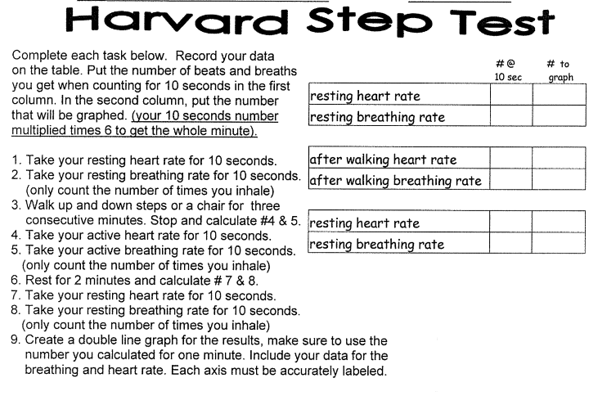

**Data (20 points)**

| **Activity** | **Count in 10 seconds** | **Count in 1 minute (graph this data)** |
| --- | --- | --- |
| **Resting heart rate** | 17 | 102 |
| **Resting breathing rate** | 3 | 18 |
|  |  |  |
| **After walking heart rate** | 25 | 150 |
| **After walking breathing rate** | 7 | 42 |
| *rest 2 minutes |  |  |
| **Resting heart rate** | 10 | 60 |
| **Resting breathing rate** | 3 | 18 |

**Graph (please insert here and shrink to fit space) (2o points)**

**Turned in on Paper.**

-create a line graph,  *there should be two lines- one for breathing rate and one for heart rate*

*In Kid Zone: use 3 items (resting 1, active, resting 2) and 2 groups (heart rate, breathing rate);X-Axis is Activity Level and Y-axis is rate (# per minute)*

-graph heart rate and breathing rate for 1 minute

-label axes properly

**Reasoning**

**Use the rubric to guide the amount of detail you use in your PARAGRAPH**

*-How was the claim supported by your data and research? Thoroughly explain. (use the following questions to guide your reasoning; these are hints, not all inclusive)*

*-start paragraph with a topic statement using the CLAIM (4 points)*

-did your heart rate and breathing rate increase with activity? (4)

-did your heart rate and breathing rate decrease after rest? (4)

-why do you need more blood flow during activity? (4)

-why do you need to breathe more during activity? (4)

*-end with a conclusion related to the claim (4)*

**Further Analysis**

**Answer the following using complete and detailed sentences**

**Claim- 1 point**

**Evidence- from research and class discussions- 2 to 3 items of evidence (3)**

**Reasoning- explanation (2)**

**Answers do not need to make a paragraph, but must be detailed.** 5 points each

*-Based on the readings, how healthy is your heart rate and breathing rate? Explain.*

*-what can you do to improve your health or maintain your health?*

*-what can you do to avoid becoming unhealthy (in terms of heart and lung function)*

*-what is your target heart rate?*

**Claim-Evidence-Reasoning Rubric**

**How do you connect data to the background information in order to analyze?**

|  | **4**  **Advanced** | **3**  **Proficient** | **2**  **Progressing** | **1**  **Beginning** |
| --- | --- | --- | --- | --- |
| **Claim**  *A statement or conclusion that answers the original question/ problem.* | * Makes a claim that is relevant, accurate, and complete. * Contrasts the claim to an alternative claim. | Makes a claim that is…   * Relevant (Directly & clearly responds to question) * Accurate (Consistent with evidence and scientific principles) * Complete (Complete sentence that stands alone) | • Makes a relevant and accurate but incomplete claim. | • Does not make a claim, or makes an inaccurate or irrelevant claim. |
| **Evidence**  *Scientific data that supports the claim. The data needs to be appropriate and sufficient to support the claim.* | * Provides appropriate and sufficient evidence to support the claim. * Discusses evidence that would support alternative claims. | Provides evidence to support the claim that is…   * Appropriate (Scientific data or information from observations, investigations, data analysis, or valid scientific sources) * Sufficient (Enough evidence to support the claim) | • Provides appropriate, but insufficient evidence to support the claim. May include some inappropriate evidence. | • Does not provide evidence, or only provides inappropriate evidence (Evidence that does not support the claim). |
| **Reasoning**  *A justification that connects the evidence to the claim. It shows why the data counts as evidence by using appropriate and sufficient scientific principles.* | * Provides reasoning that clearly connects the evidence to the claim. * Includes appropriate and sufficient scientific principles to explain why the evidence supports the claim. * Explains why the alternative claim is inaccurate. | Explanation provides reasoning that is…   * Clear (Clearly communicated and goes beyond repeating claim and evidence) * Connected (Explains why the evidence is important or why it is relevant) * Integrated (Links the evidence to an important disciplinary idea and crosscutting concept) | • Provides reasoning that connects the evidence to the claim. May include some scientific principles or justification for why the evidence supports the claim, but not sufficient. | • Does not provide reasoning, or only provides inappropriate reasoning. |

McKenzie, Loz

Mrs. Gallivan

Science G

3 - 19 - 2024

Harvard Step Test Analysis

Heart rate is determined by what you are doing whether it be exercising or just sitting down. Your heart rate is determined by your age and health. For example: If you are healthy then regular 20 year olds should have a 100-170 beats per minute (bpm) and their maximum should be 200. To determine how healthy your respiratory rate can be you can look at the ages of certain people like the heart rate. For example: A normal person over the age of 18 should have 12 to 20 breaths per minute. To test both heart rate and respiratory rate you can exercise and see how it affects your body. Before the experiment I looked at my target heart rate and found it is 102 beats when I am resting and 150 when I am exercising. During my experiment, we had a specific plan which tested breathing and heart rate to see if our systems increased more or less after the activity. While doing the activity I checked my heart rate and breathing rate to see if it increased and it did with my heart rate being 150 while my respiratory rate was 48. After I sat down my breathing rate returned to normal, while my heart rate went from 102 to 60. My respiratory and heart rate increased from doing an activity and decreased by resting. Your blood flow is a contributing factor for health and physical activity. For example: Pumping more blood will deliver oxygen to your muscles to stay functional. After looking through my data I have a healthy heart and breathing rate with my breathing rate 18 when I exercise with my breathing rate being 18 when I am normal and 42 when I am exercising. My heart rate is in the 100s to 150s so I am fine. To make sure I am fit and healthy I can work out, eat vegetables, consume fruits, a proper diet and limit the amount of salt and cholesterol I have. Also I can avoid junk food and not eat sugar all the time.